**Personal Blog On IBM Cloud Static Web App**

**Problem Design And Innovation**

|  |  |
| --- | --- |
| **Date** | **10-10-2023** |
| **Team ID** | **678** |
| **Project Name** | **Personal Blog On IBM Cloud Static Web App** |

**Problem Statement:**

 Create a personal travel blog hosted on IBM Cloud Static Web Apps. Share your travel adventures, tips, and captivating photos with the world. Use IBM Cloud Static Web Apps to easily update your blog and document your journeys. Inspire others to explore the beauty of the world and forge unforgettable memories!

**1. Introduction**

The task at hand is to create a personal blog, which has never been easier. Whether you want to share your thoughts, experiences, or expertise with the world, having an online platform is essential. However, not all hosting solutions are created equal, and this is where IBM Cloud's Static Web App service comes into play.

In this blog, we'll embark on a journey to explore the capabilities of IBM Cloud's Static Web App service and how it can be leveraged to build and host a personal blog. IBM Cloud, with its robust infrastructure and developer-friendly tools, offers an ideal environment for web application deployment.

**2. Problem Statement:**

Objective: Travel bloggers aiming to establish a static website hosted on the cloud encounter the challenge of differentiating themselves in a saturated online travel content market. They often lack a clear strategy to create an engaging and informative platform that effectively captures the essence of their adventures. This results in difficulties in attracting and retaining an audience, as well as difficulties in optimizing their website for reliable and scalable cloud hosting.

**3. Design Thinking Approach**

**3.1. Data Collection and Feature Engineering**

Innovation: Comprehensive Data Gathering

Implement advanced website analytics techniques implement tools like Google Analytics or similar platforms to collect data on website traffic, user behaviour, and audience demographics. Social media metrics to track your social media performances, including follower growth, engagement rates and post reach. Competitor Analysis to Study your competitors' blogs and websites. Analyse their content, engagement strategies, and audience demographics to identify gaps you can fill or opportunities for differentiation.

**3.2. Data Pre-processing**

Data pre-processing is a crucial step in making sense of the data you've collected and preparing it for analysis or feature engineering.

Remove duplicates check for and remove duplicate records or entries to ensure your data is clean.

Merge data sources if you have data from multiple sources (e.g., website analytics, social media metrics), integrate them into a single dataset for analysis.Create visualizations:

Generate plots, charts, and graphs to visualize your data. This can help you identify patterns, trends, and outliers.

**3.3. Model Selection and Training**

Selecting the right model and training it effectively is crucial for addressing the challenges faced by travel bloggers aiming to establish a static website in a competitive market**.**

Ensure that your data is clean, pre-processed, and organized. It should be in a format suitable for machine learning. If you're using multiple data sources, integrate them into a unified dataset.

To improve content recommendations, consider using content-based recommendation systems that recommend content similar to what users have previously interacted with.

**3.4. Geographic Analysis**

Leverage geographic analytics tools to gain insights into your audience's geographic distribution. Understand where your readers are located and tailor your content to their preferences. Google Analytics and other web analytics platforms can provide geographic data**.**

**3.5. Market Sentiment Analysis**

Monitor social media platforms, travel forums, and blogs to gather user-generated content and comments related to travel. Tools like Brand watch, Mention, or Hootsuite can help automate this process.

Utilize sentiment analysis tools and natural language processing (NLP) algorithms to analyse the sentiment of user-generated content. These tools can classify comments, reviews, and mentions as positive, negative, or neutral.

Directly engage with your audience through surveys or feedback forms on your website or social media. Ask questions about their preferences, pain points, and what they enjoy in travel content.

Analyse sentiment trends related to travel destinations, types of travel, and travel experiences. Identify which trends are currently resonating with the audience.

**3.6. Explainable AI (XAI)**

Explainable AI (XAI) can be a valuable tool for travel bloggers aiming to address the challenges of differentiating themselves in a competitive online travel content market.

XAI enables the transparency and interpretability of AI algorithms, allowing bloggers to make data-driven decisions to enhance their platform.

Implement an XAI-driven recommendation system on your website. This system can analyse user behaviour, preferences, and historical interactions to suggest relevant travel content

By analysing user data, such as browsing history and location, XAI can help tailor content and offers to individual user preferences.

Employ XAI to analyse user engagement metrics, such as click-through rates, time spent on pages, and bounce rates. With XAI, bloggers can gain insights into which types of content or website features are most effective in engaging their audience

**3.7. Continuous Learning**

Continuous learning is essential for travel bloggers looking to succeed in a saturated online travel content market. It allows bloggers to adapt to evolving trends, improve their strategies, and continuously engage and retain their audience.

Regularly read travel-related publications, follow industry influencers, and subscribe to newsletters to stay informed about the latest trends in travel, blogging, and digital marketing

Connect with fellow travel bloggers, influencers, and professionals in the industry through social media, forums, and networking events

Continuously monitor website analytics to understand user behaviour and preferences. Analyse user feedback and comments to identify areas for improvement and optimization.

Stay attuned to changes in user preferences. If your audience begins to show interest in a new type of content or destination, be ready to pivot and create content that aligns with their interests.

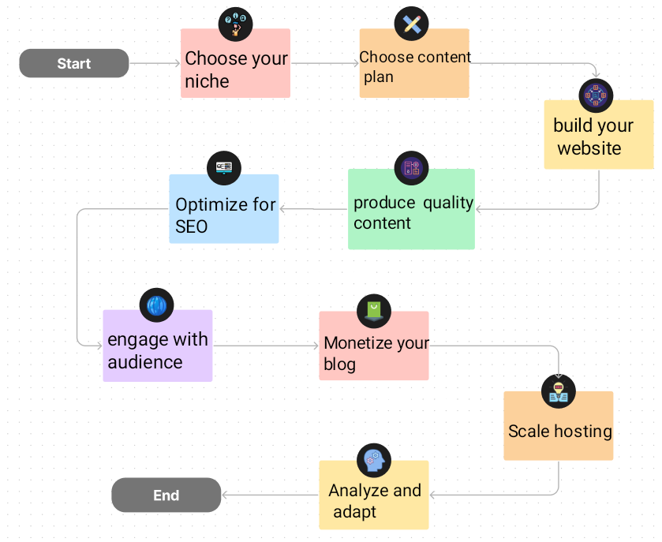

**Innovation:**

Consider integrating social media sharing buttons, interactive maps, and comment sections to enhance user engagement and interaction.

**1 . Social Media Sharing Buttons:**

**Use:**Easily share your favorite travel stories, tips, and photos with your friends and followers on various social media platforms. Just click on the sharing icons below each blog post to spread the Love of travel.

**2.Interactive Map:**

**Use:**explore about each location. These maps will help you plan your own adventures or take a virtual tour of the places Explore the destinations I've ventured to through interactive maps. Zoom in, click on markers, and uncover more details I've visited.

**3. Comment Section:**

**Use:**Share your thoughts, experiences, and questions in the comment sections below each blog post. Let's create a vibrant community of travel enthusiasts who can exchange insights and inspire one another.

**Tools:**

1. HTML
2. CSS
3. JAVA SCRIPT
4. FLASK

**Flow Chart:**

**Star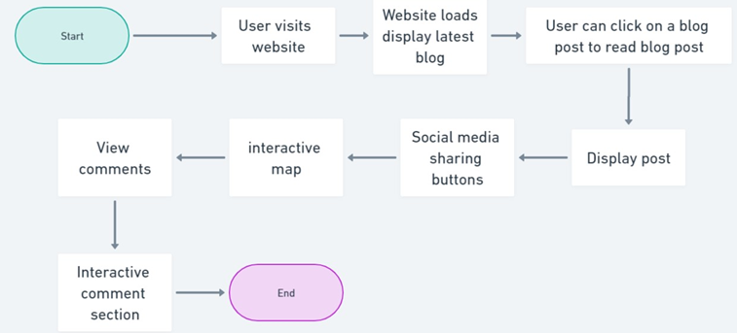t**

**Conclusion:**

Creating a travel blog with features like social media sharing, interactive maps, and comments requires web development skills and integration with various technologies. Plan your content, design a user-friendly layout, implement functionality, and continuously improve your blog. It's a journey of sharing your travel passion and inspiring others to explore the world.

**|--- User visits the travel blog website**

**| |**

**| |--- Website loads and displays the latest blog posts**

**| |**

**| |--- User can click on a blog post to read it**

**| |**

**| |--- Display the selected blog post with text and images**

**| |**

**| |--- User can click on social media sharing buttons**

**| | |**

**| | |--- Share on Facebook**

**| | |**

**| | |--- Share on Twitter**

**| | |**

**| | |--- Share on In**

**| |**

**| |--- User can view an interactive map of the destination**

**| | |**

**| |--- Display the map with mark**